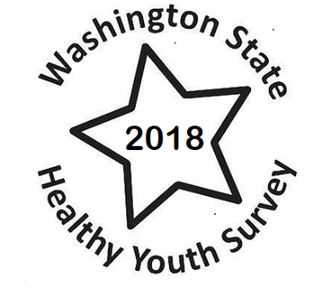

Washington State 2018 Healthy Youth Survey

Our district is participating in the Washington State 2018 Healthy Youth Survey during fall 2018.

The Healthy Youth survey includes questions related to physical activity and diet, unintentional and intentional injury, substance use, risk and protective factors, access to school-based services, and sexual behaviors, abuse and orientation. Survey results are used by schools, communities and state agencies to plan programs to support our youth and reduce their risks.

Participation in the survey is voluntary and the students’ answers are anonymous.

Please read the Parent and Student Notification Letter for more information about the Healthy Youth Survey.

