May 13, 2021
Waterville School Staff and Community,
Included please find our weekly report of staff and students excluded from school for COVID Like Illness (CLI). This information is submitted to Chelan Douglas Health District by our school nurse each week.
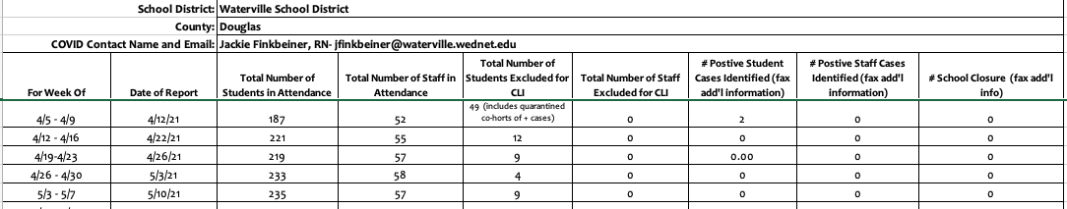
*These exclusion times and processes are included in the Region 7 flow chart sent to all families. This flow chart is based on guidance established by the CDC.
Region 7 Flow Chart: (Updated March 24)
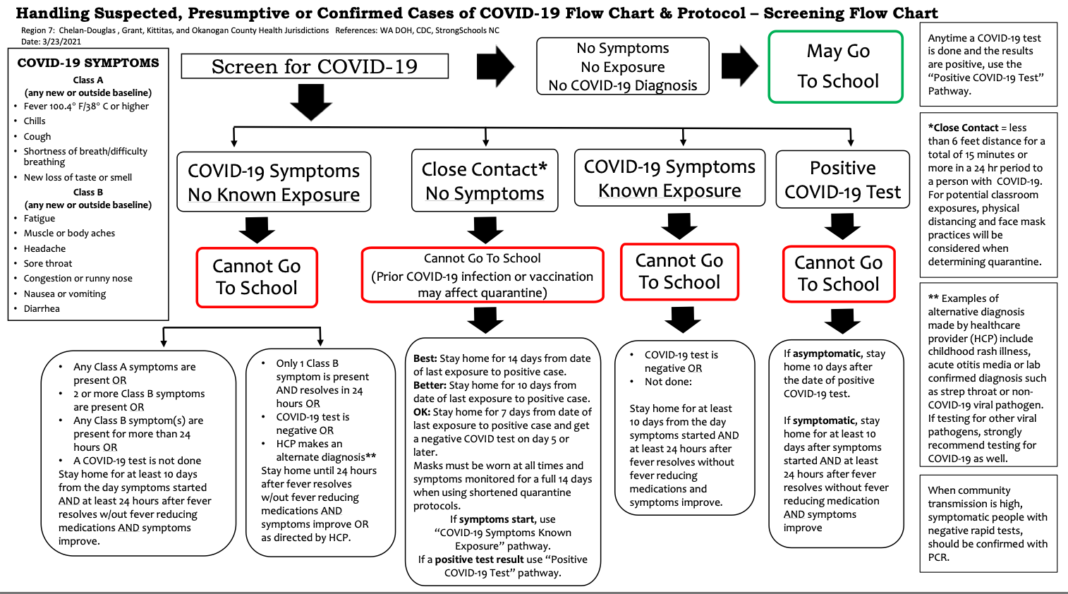
*Each case of exposure, symptoms, or positive screening is followed on an individual basis using this required process.
Regional Information from WA DOH Risk Assessment Dashboard: https://coronavirus.wa.gov/what-you-need-know/roadmap-recovery-metrics
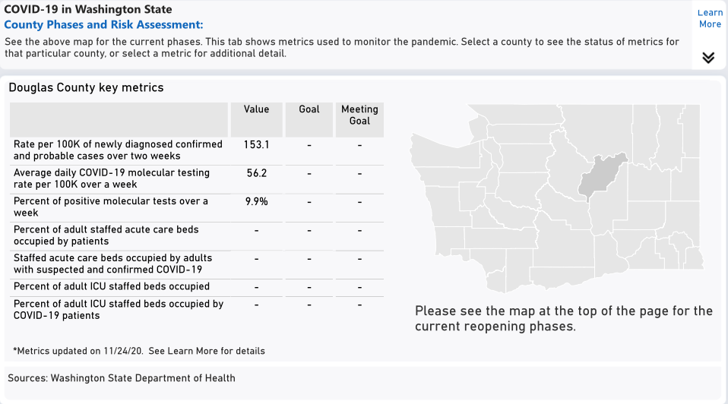
Mission:
Cultivating Leaders who THRIVE (Trust, Honor, Respect, Integrity, Valor, Evolving Excellence)
Motto
Leave a Legacy

We believe:
All children have genius, and everyone is a leader.
Providing a strong basic education to all students is a moral imperative.
Diversity enhances a strong and healthy community.
Change starts with me, and growth is the key to learning.
The whole child is important.
All students deserve a safe, equitable, accessible and inclusive learning environment.
All means all.
Additional Information from our School Community:
- While the CDC continues to update masking guidance, schools are still required to follow DOH and Washington requirements for masking in indoor spaces and most outdoor spaces for our staff and students and for spectators and guests in our buildings (regardless of vaccination status). We will continue to follow all school requirements in order to keep our staff and students safe and ensure compliance with all school mandates.
- Students age 12 and above are now eligible for the COVID 19 vaccine. Visit https://prepmod.doh.wa.gov/appointment/en/client/registration?clinic_id=3564 to make an appointment for your child.

Our very best to you and yours,
Tabatha Mires
Waterville School District Superintendent/HS Principal

Mayo 13, 2021
Personal de la Escuela Waterville y Comunidad,
Incluido está el reporte semanal del personal y estudiantes excluidos de la escuela por enfermedades parecidas al COVID. Esta información es enviada al Distrito de Salud Chelan Douglas por nuestra enfermera escolar cada semana.
**Estos tiempos de exclusiones y procesos incluido en el diagrama grafico Región 7 enviada a todas las familias. Este diagrama está basado en la guia establecida por el CDC.
****Información incluye los datos de la semana pasada

Diagrama de Flujo de la Región 7 (Actualizado marzo 24)
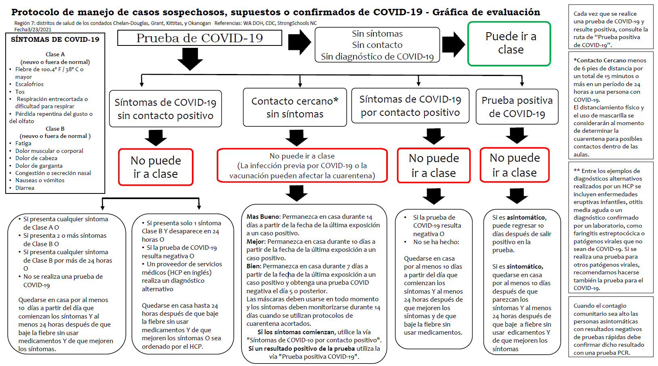

*Cada caso de exposición, síntomas, o detección positiva se sigue de forma individual mediante este proceso requerido.

Información Regional de WA DOH Panel de Evaluación de Riesgos: https://coronavirus.wa.gov/what-you-need-know/roadmap-recovery-metrics

Mission:
Cultivating Leaders who THRIVE (Trust, Honor, Respect, Integrity, Valor, Evolving Excellence)
Motto
Leave a Legacy

We believe:
All children have genius, and everyone is a leader.
Providing a strong basic education to all students is a moral imperative.
Diversity enhances a strong and healthy community.
Change starts with me, and growth is the key to learning.
The whole child is important.
All students deserve a safe, equitable, accessible and inclusive learning environment.
All means all.

Información adicional de nuestra comunidad escolar:
- Mientras los del CDC continua en actualizando las orientaciones de enmascaramiento , las escuelas todavía son requeridas en seguir los requisitos del DOH y Washington de enmascaramiento en espacios interiores y la mayoría de los espacios al aire libre para nuestro personal y estudiantes y para espectadores e invitados en nuestros edificios (sin importar el estado de vacunación). Continuaremos siguiendo todos los requisitos de la escuela para mantener a nuestro personal y estudiantes seguros y asegurar el cumplimiento con todos los mandatos de la escuela.
- Los estudiantes de 12 años o as ahora son elegibles para recibir la vacuna de COVID 19. Visite https://prepmod.doh.wa.gov/appointment/en/client/registration?clinic_id=3564 para programar una cita para su hijo.
Lo mejor para usted y los suyos,
Tabatha Mires
Superintendente del Distrito Escolar Waterville/Directora

