January 7, 2021
Waterville School Staff and Community,
Included please find our weekly report of staff and students excluded from school for COVID Like Illness (CLI). This information is submitted to Chelan Douglas Health District by our school nurse each week. In addition, I have included today’s newest information about the phase our region (North Central) is currently in. For more information about the phase system, please visit: https://www.governor.wa.gov/sites/default/files/HealthyWashington.pdf?utm_medium=email&utm_source=govdelivery
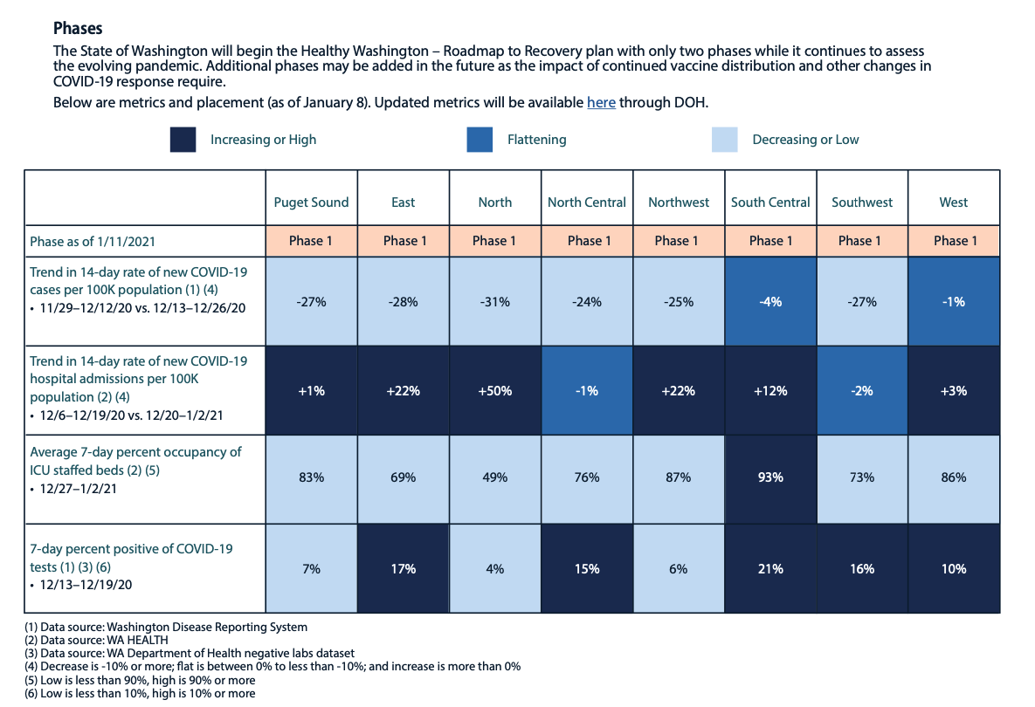
Waterville School Dashboard
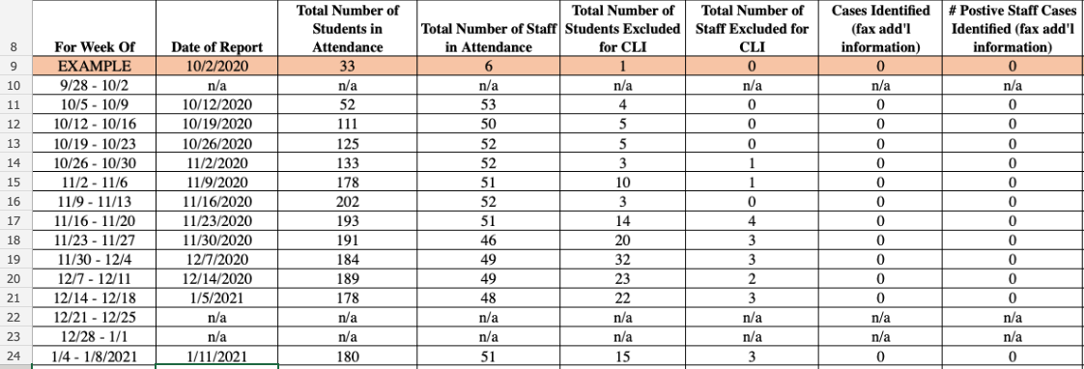
*These exclusion times and processes are included in the Region 7 flow chart sent to all families. This flow chart is based on guidance established by the CDC.
** Information includes the previous week’s data.

Region 7 Flow Chart:
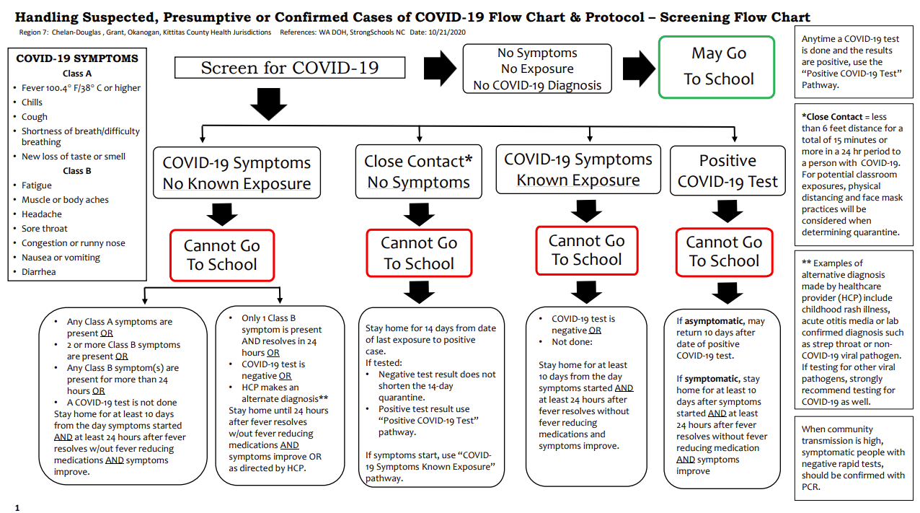
*Each case of exposure, symptoms, or positive screening is followed on an individual basis using this required process.

Regional Information from Chelan Douglas Health District:
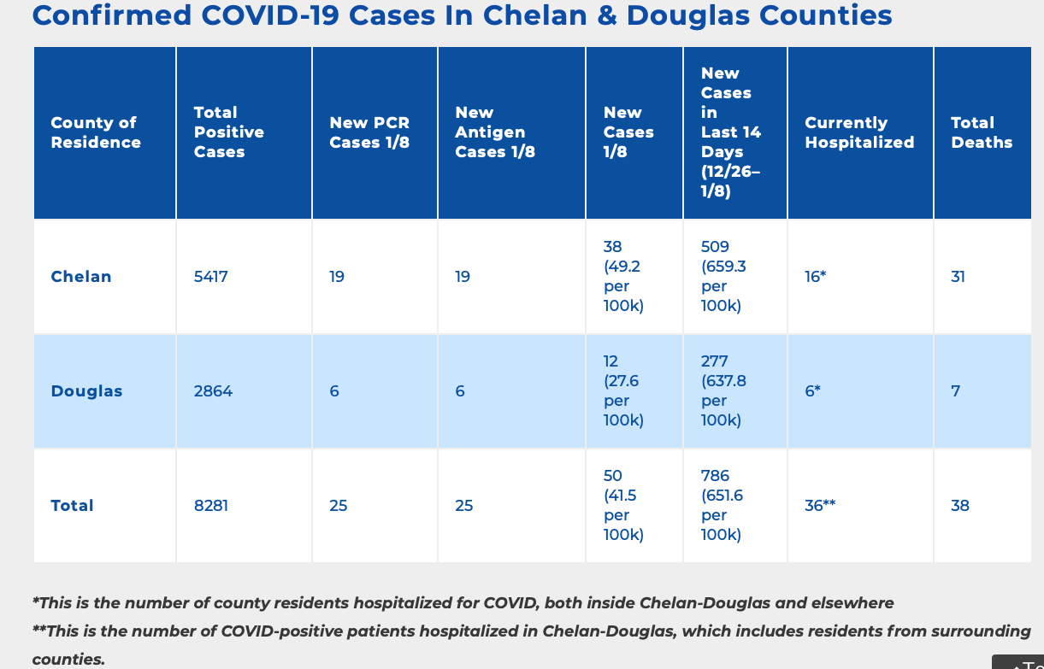

Further information from Waterville School:
We are excited to announce further vaccinations of staff working in isolation rooms, with our youngest learners and in life skills settings.

Mission:
Cultivating Leaders who THRIVE (Trust, Honor, Respect, Integrity, Valor, Evolving Excellence)
Motto
Leave a Legacy

We believe:
All children have genius, and everyone is a leader.
Providing a strong basic education to all students is a moral imperative.
Diversity enhances a strong and healthy community.
Change starts with me, and growth is the key to learning.
The whole child is important.
All students deserve a safe, equitable, accessible and inclusive learning environment.
All means all.

Our very best to you and yours,
Tabatha Mires
Waterville School District Superintendent/HS Principal

